**MEMBUAT QUERY**

1. [SELECT](http://localhost/phpmyadmin/url.php?url=https://dev.mysql.com/doc/refman/5.5/en/select.html) * FROM `obat` ORDER BY merk DESC

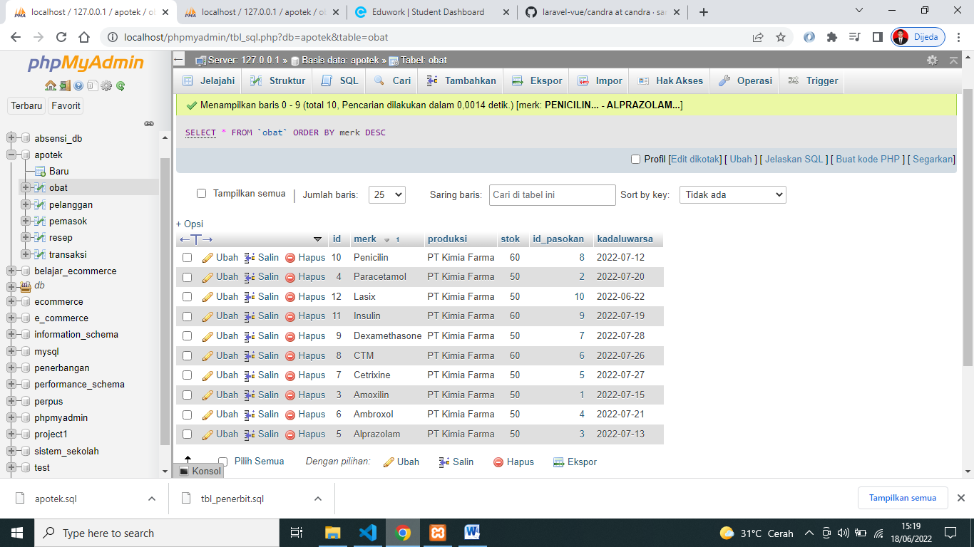

1. [SELECT](http://localhost/phpmyadmin/url.php?url=https://dev.mysql.com/doc/refman/5.5/en/select.html) merk, produksi, stok, kadaluwarsa FROM `obat` ORDER BY kadaluwarsa ASC

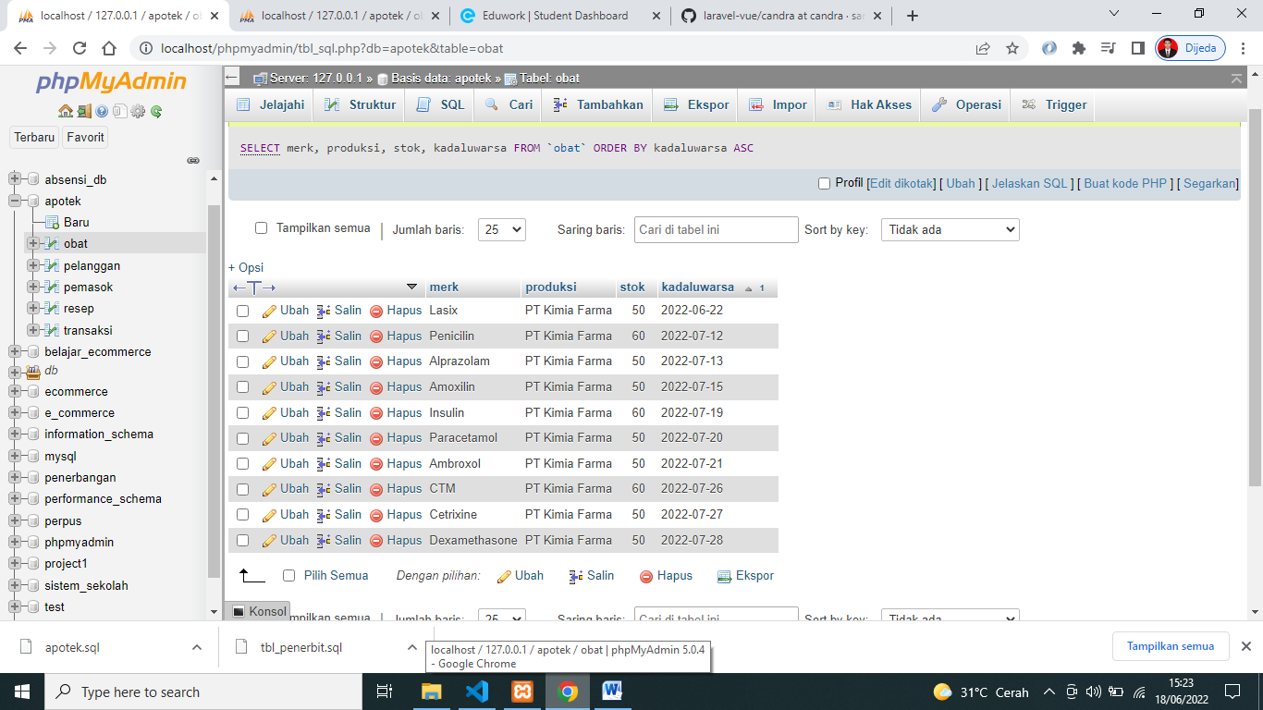

1. [SELECT](http://localhost/phpmyadmin/url.php?url=https://dev.mysql.com/doc/refman/5.5/en/select.html) * FROM `obat` WHERE produksi [LIKE](http://localhost/phpmyadmin/url.php?url=https://dev.mysql.com/doc/refman/5.5/en/string-comparison-functions.html#operator_like) '%Index%'

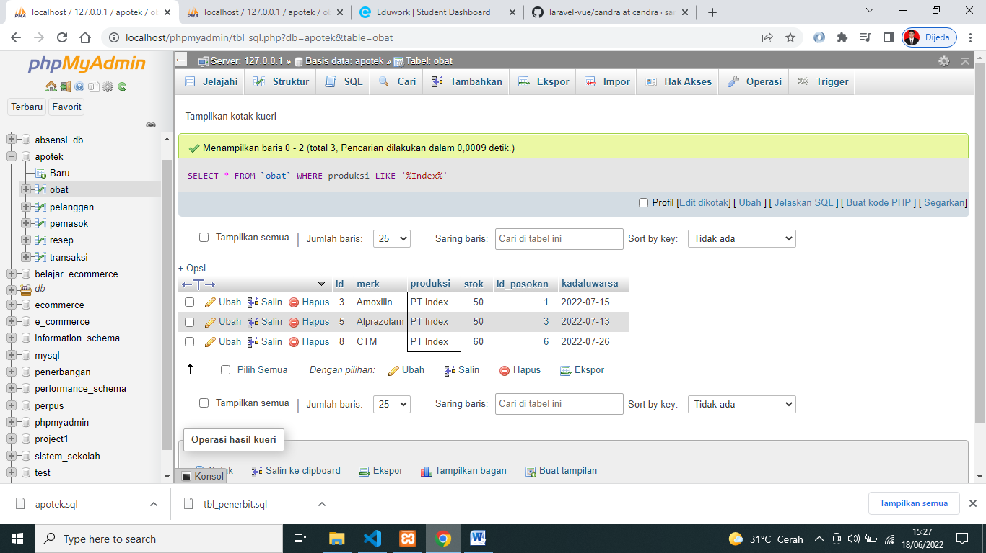

1. [SELECT](http://localhost/phpmyadmin/url.php?url=https://dev.mysql.com/doc/refman/5.5/en/select.html) * FROM `resep` WHERE dokter [LIKE](http://localhost/phpmyadmin/url.php?url=https://dev.mysql.com/doc/refman/5.5/en/string-comparison-functions.html#operator_like) '%Ox%'

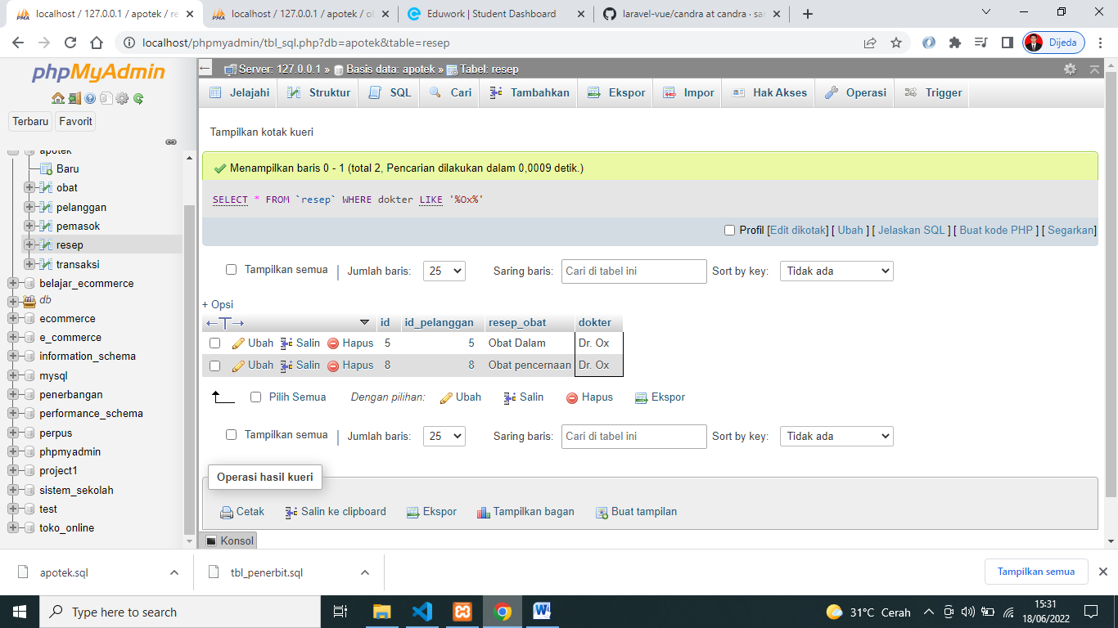

1. [SELECT](http://localhost/phpmyadmin/url.php?url=https://dev.mysql.com/doc/refman/5.5/en/select.html) id_pasokan, [SUM](http://localhost/phpmyadmin/url.php?url=https://dev.mysql.com/doc/refman/5.5/en/group-by-functions.html#function_sum)(stok) as Stok FROM `obat` GROUP BY id_pasokan

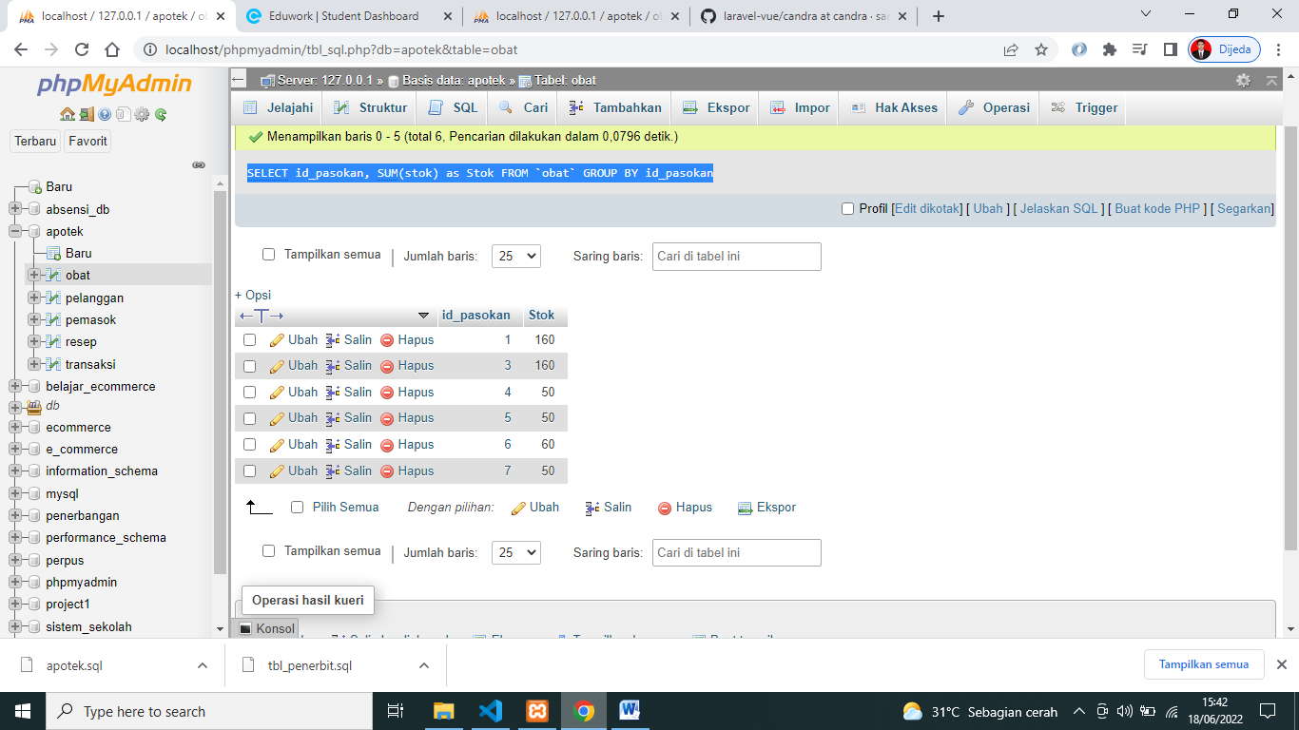

1. [SELECT](http://localhost/phpmyadmin/url.php?url=https://dev.mysql.com/doc/refman/5.5/en/select.html) id_pasokan, [SUM](http://localhost/phpmyadmin/url.php?url=https://dev.mysql.com/doc/refman/5.5/en/group-by-functions.html#function_sum)(stok) as Stok FROM `obat` GROUP BY id_pasokan ORDER BY id_pasokan DESC

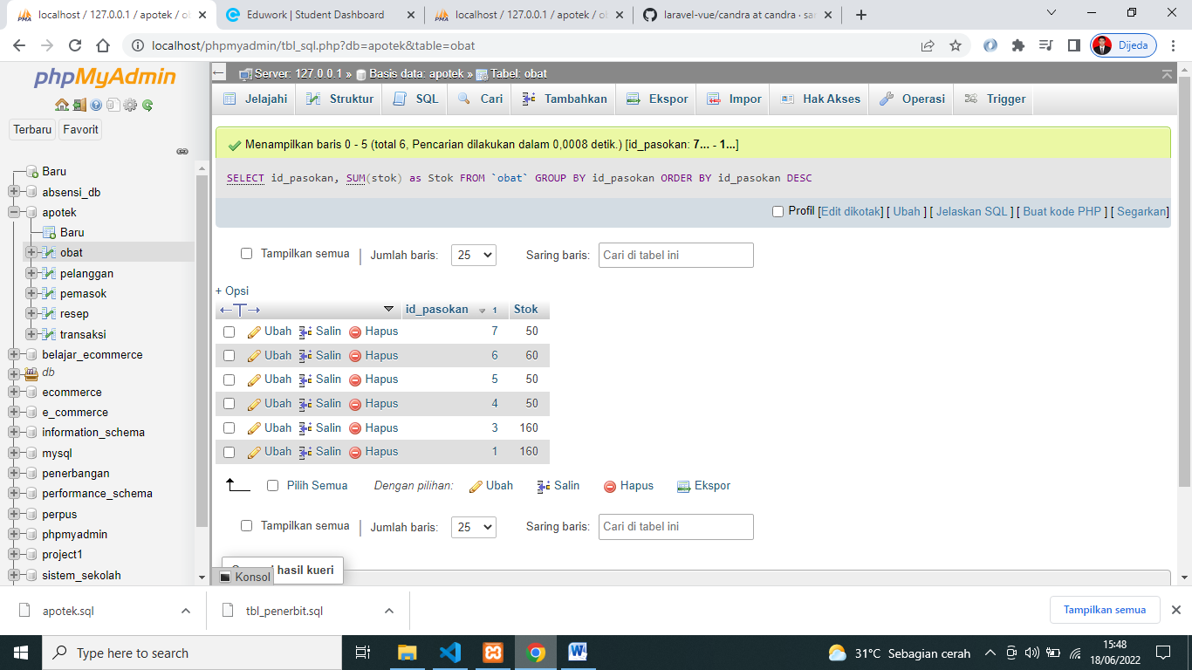

1. [SELECT](http://localhost/phpmyadmin/url.php?url=https://dev.mysql.com/doc/refman/5.5/en/select.html) id_pasokan, [SUM](http://localhost/phpmyadmin/url.php?url=https://dev.mysql.com/doc/refman/5.5/en/group-by-functions.html#function_sum)(stok) as Stok FROM `obat` GROUP BY id_pasokan ORDER BY id_pasokan ASC

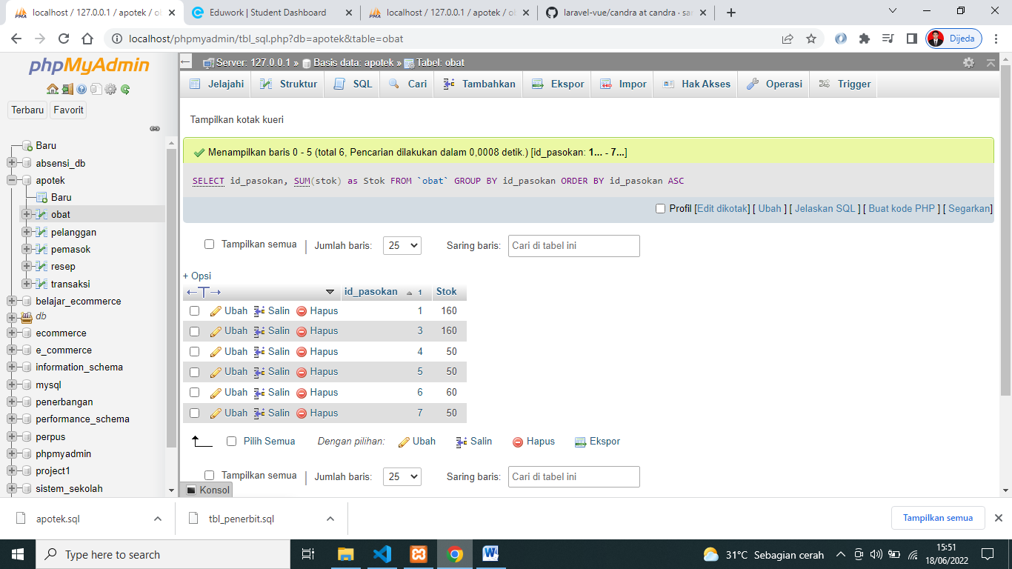

1. [SELECT](http://localhost/phpmyadmin/url.php?url=https://dev.mysql.com/doc/refman/5.5/en/select.html) id_pelanggan, [SUM](http://localhost/phpmyadmin/url.php?url=https://dev.mysql.com/doc/refman/5.5/en/group-by-functions.html#function_sum)(harga) as Total FROM `transaksi` GROUP BY id_pelanggan

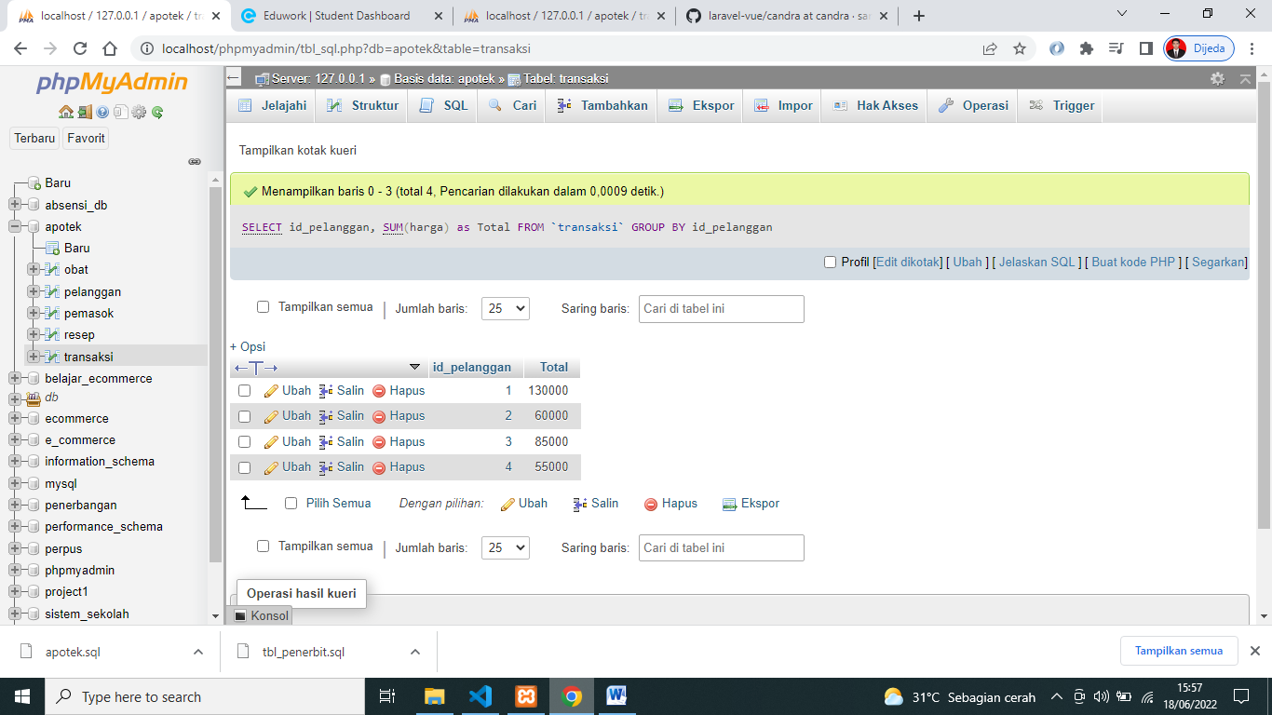

1. [SELECT](http://localhost/phpmyadmin/url.php?url=https://dev.mysql.com/doc/refman/5.5/en/select.html) id_pelanggan, [SUM](http://localhost/phpmyadmin/url.php?url=https://dev.mysql.com/doc/refman/5.5/en/group-by-functions.html#function_sum)(harga) as Total FROM `transaksi` GROUP BY id_pelanggan ORDER BY id_pelanggan DESC

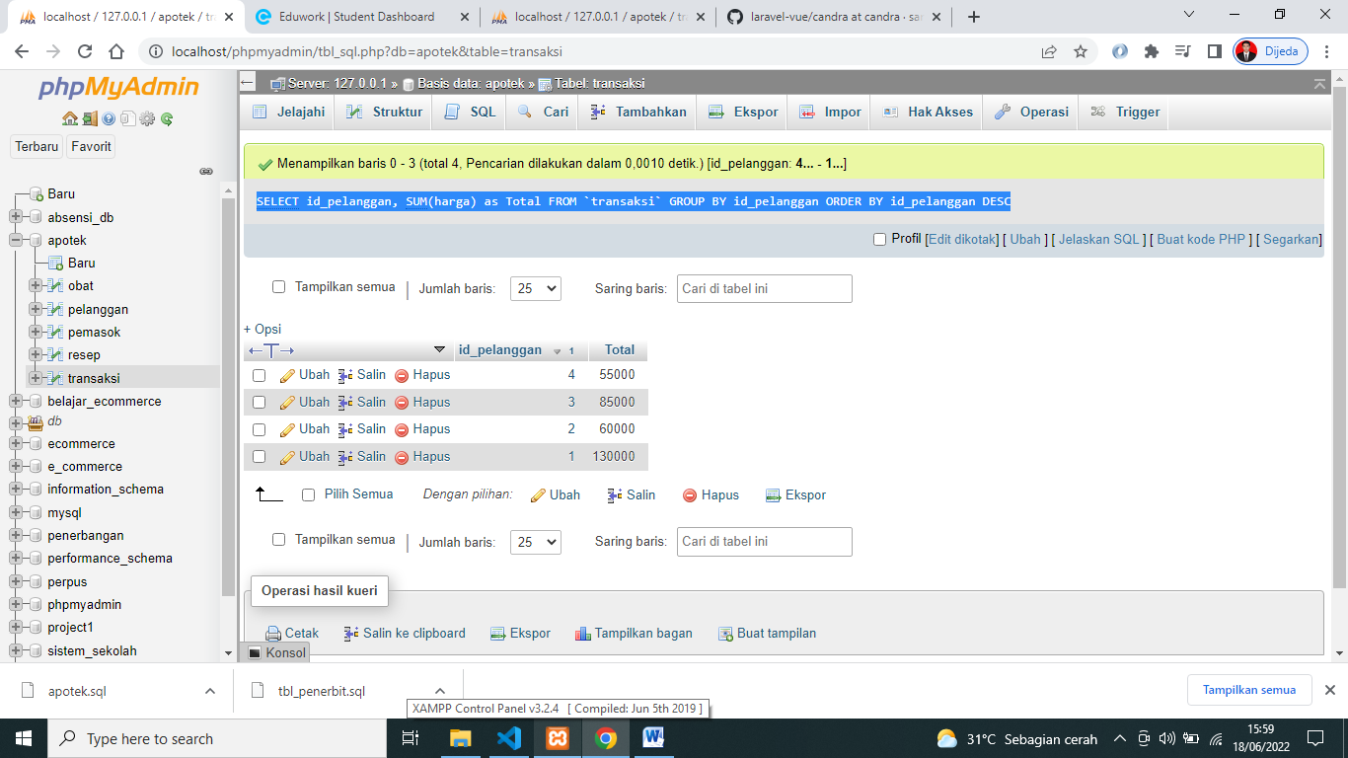

1. [SELECT](http://localhost/phpmyadmin/url.php?url=https://dev.mysql.com/doc/refman/5.5/en/select.html) id_pelanggan, tanggal, [SUM](http://localhost/phpmyadmin/url.php?url=https://dev.mysql.com/doc/refman/5.5/en/group-by-functions.html#function_sum)(harga) as Total FROM `transaksi` WHERE tanggal > '2022-06-21' GROUP BY id_pelanggan

